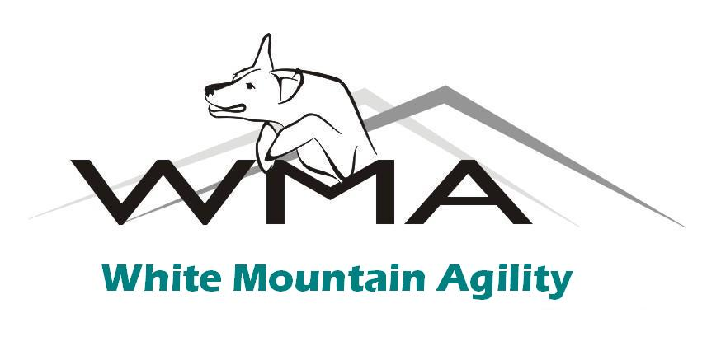
Announcing A Julie Daniels PERSONAL BEST Weekend
July 6-7, 2013
With Julie’s Master Level Agility Classes, and Featuring
Karen Kay’s Individualized Self-Improvement Program for Every Working Participant!
Also Dynamic Group Warm-Ups, Yoga Classes, and Trail Running With Your Dog!

$350 includes materials plus Saturday night dinner and program, and breakfast and lunch each day!
Lots of Floor Time! Individual Movement Screens and Corrective Exercises!
Improve your Skills, your Delivery, your Effectiveness, your Fitness, your Success!
Please sign me up for the July 6-7 PERSONAL BEST Weekend at WMA!
I am enclosing: ________$350 for Working Spot (Limited to 12) ________$50 per additional dog ________$150 for Auditor Spot (Without Dog)

Handler: ___________________________________________ Phone: ___________________________

Email: ________________________________________________________________________________

Address: ______________________________________________________________________________

City: ________________________________ State: __________ Zip/Postal Code: ________________

Dog’s Name:____________________Age:_________Breed____________________Sex_____Intact?____

Extra Dogs Coming?_________Number of Extra Dogs ($50 each)__________(Please describe on back!)

Your Agility/Fitness Experience? ________________________________________________________

Waiver: I realize that a dog agility/fitness event involves risk and can be dangerous. I expressly assume these risks and hold White Mountain Agility and its Instructors harmless, and I expressly assume all responsibility for the actions of my dog(s), myself, and my guests while at White Mountain Agility events.
Signature of Responsible Party (Handler of Dog): _____________________________________________

see the facility at www.WhiteMountainAgility.net
Email Julie: JulieDaniels@whitemountainagility.net

