Winter Camp Weekend!
Sat-Sun, Feb 7-8, 2015
Agility and Snowshoe Camp with Julie Daniels
Limited to 8 Handlers!!
At White Mountain Agility, 100 acres of dog heaven
with indoor arena and miles of groomed trails
GPS address: 431 Chase Rd, North Sandwich, NH 03259

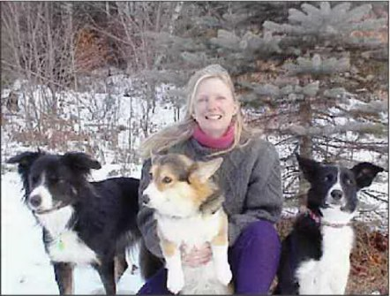
________________________________________________________________________________________________

Sign Me Up for the Winter Camp Weekend, Feb 7-8, 2015 with Julie Daniels at White Mountain Agility
I enclose $300 per handler with one dog; $50 extra for each additional dog. Auditor spots $100__________
Please Note: Non-working family members are Auditors! Auditors may bring one dog.
Each Auditor must fill out a separate Registration Form including signed waiver. Thank you!
(Trust me, everyone wants to bring family here, but these Camps are kept small by design!)
Checks payable to: WMA Mail to: White Mountain Agility, 431 Chase Rd., N. Sandwich, NH 03259.
Dog’s Name_____________________________ Breed (Mix)____________________ Age_____________ M/F/N
Agility Experience_________________________________________________________________________
Second Dog (Add $50)__________________________ Breed____________________ Age_____________ M/F/N
Agility Experience______________________________________________________________________________
Handler’s Name__________________________________________ Phone________________________________
Address_______________________________________________________________________________________
E-mail_________________________________________________________________________________________

Waiver: I accept responsibility for the behavior of my dog, myself, and my guests at this Agility/Snowshoe weekend.
Dogs are unpredictable and I accept the risks inherent in this dog training and indoor/outdoor activities event.
Signed, ____________________________________________ (Adult Handler of Dog) Date____________________
Questions? Call Julie at 603-284-7200 or email JulieDaniels@WhiteMountainAgility.net

