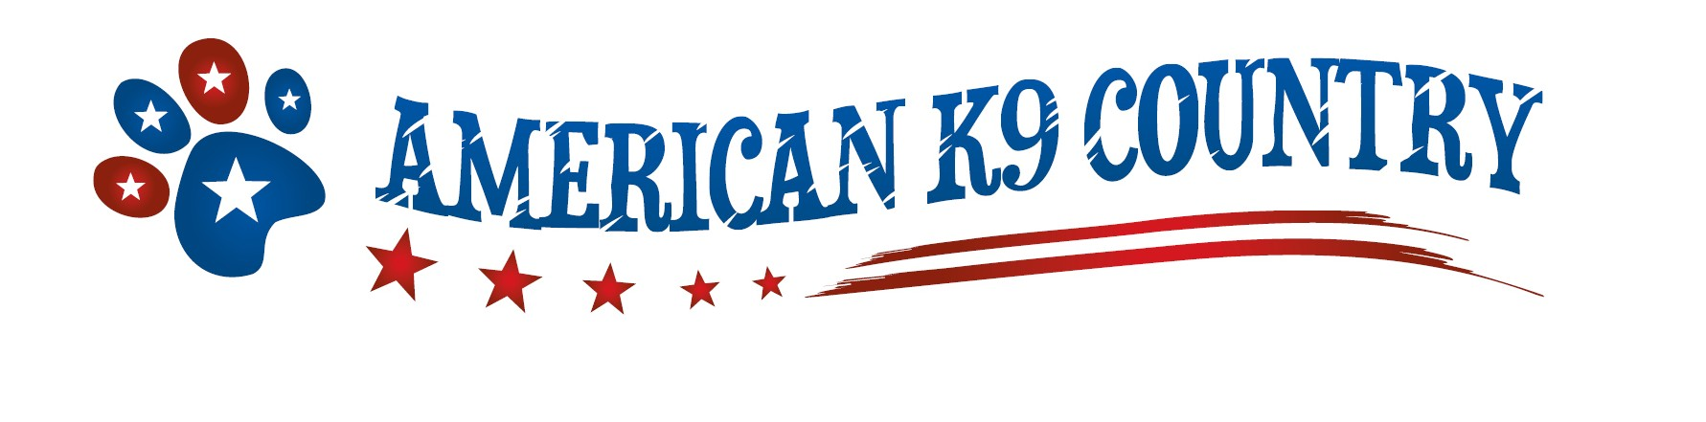

Friday December 13, 2013
9:30Am-2:30pm
**Handling for Prime Time**

This workshop is for advanced dog & handler teams.
Julie will cover:
Fun & Challenging Masters Level Courses
Advanced Skill Sets & Full Course Work!
Lots of floor time! WHOLE arena!
$125 Workers. Auditors $50
LIMITED to 10 Workers!!

AK9C is conveniently located on Routes 101 just over the Bedford Line across from Camp Rd in Amherst. For detailed directions please visit our website @:
www.Americank9country.com
To register mail this form to AK9C 336 Route 101 Amherst, NH 03031

Name: | Dog’s name | Main Jump ht. you wish to run
Phone: | Breed | Circle Work Audit
Email: |  | Total Cost  $

I hereby release American K9 Country, its employees, officers, instructors, members and agents from any and all liability of any nature, for any and all injury and/or damages which I or my dog may suffer, while participating and/or attending this event, these training grounds or the surrounding area. I agree to hold harmless American K9 Country and its agents for any and all injuries that myself or my animal may suffer.

Signature_________________________________________________Date_________________

